**CTS DIGITAL NURTURE - 4.0 JAVA FSE**

**WEEK 5 -** **Microservices with Spring Boot 3 and Spring Cloud**

**2. Microservices with API gateway**

**Microservices with API Gateway**

**Enabling API Gateway for Loan, Accounts microservices**

PROGRAM:

**For api-gateway:**

**application.yaml**

spring:

application:

name: api-gateway

main:

web-application-type: reactive

cloud:

gateway:

routes:

- id: account-service

uri: lb://ACCOUNT-SERVICE

predicates:

- Path=/accounts/**

- id: loan-service

uri: lb://LOAN-SERVICE

predicates:

- Path=/loans/**

eureka:

client:

service-url:

defaultZone: http://localhost:8761/eureka

server:

port: 8085

**pom.xml**

<?xml version="1.0" encoding="UTF-8"?>

<project xmlns="http://maven.apache.org/POM/4.0.0" xmlns:xsi="http://www.w3.org/2001/XMLSchema-instance"

xsi:schemaLocation="http://maven.apache.org/POM/4.0.0 https://maven.apache.org/xsd/maven-4.0.0.xsd">

<modelVersion>4.0.0</modelVersion>

<parent>

<groupId>org.springframework.boot</groupId>

<artifactId>spring-boot-starter-parent</artifactId>

<version>3.1.8</version>

<relativePath/>

</parent>

<groupId>com.cognizant</groupId>

<artifactId>api-gateway</artifactId>

<version>0.0.1-SNAPSHOT</version>

<name>api-gateway</name>

<description>Demo project for Spring Boot</description>

<url/>

<licenses>

<license/>

</licenses>

<developers>

<developer/>

</developers>

<scm>

<connection/>

<developerConnection/>

<tag/>

<url/>

</scm>

<properties>

<java.version>17</java.version>

<spring-cloud.version>2022.0.5</spring-cloud.version>

</properties>

<dependencies>

<dependency>

<groupId>org.springframework.cloud</groupId>

<artifactId>spring-cloud-starter-netflix-eureka-client</artifactId>

</dependency>

<!-- Spring Cloud Gateway -->

<dependency>

<groupId>org.springframework.cloud</groupId>

<artifactId>spring-cloud-starter-gateway</artifactId>

</dependency>

<dependency>

<groupId>org.springframework.boot</groupId>

<artifactId>spring-boot-devtools</artifactId>

<scope>runtime</scope>

<optional>true</optional>

</dependency>

<dependency>

<groupId>org.springframework.boot</groupId>

<artifactId>spring-boot-starter-test</artifactId>

<scope>test</scope>

</dependency>

</dependencies>

<dependencyManagement>

<dependencies>

<dependency>

<groupId>org.springframework.cloud</groupId>

<artifactId>spring-cloud-dependencies</artifactId>

<version>2022.0.5</version>

<type>pom</type>

<scope>import</scope>

</dependency>

</dependencies>

</dependencyManagement>

<build>

<plugins>

<plugin>

<groupId>org.springframework.boot</groupId>

<artifactId>spring-boot-maven-plugin</artifactId>

</plugin>

</plugins>

</build>

</project>

**ApiGatewayApplication.java**

package com.cognizant.api_gateway;

import org.springframework.boot.SpringApplication;

import org.springframework.boot.autoconfigure.SpringBootApplication;

import org.springframework.cloud.client.discovery.EnableDiscoveryClient;

*@SpringBootApplication*

*@EnableDiscoveryClient*

public class ApiGatewayApplication {

public static void main(String[] args) {

SpringApplication.*run*(ApiGatewayApplication.class, args);

}

}

OUTPUT:

**In postman, enter the URL:**

<http://localhost:8085/accounts/123>

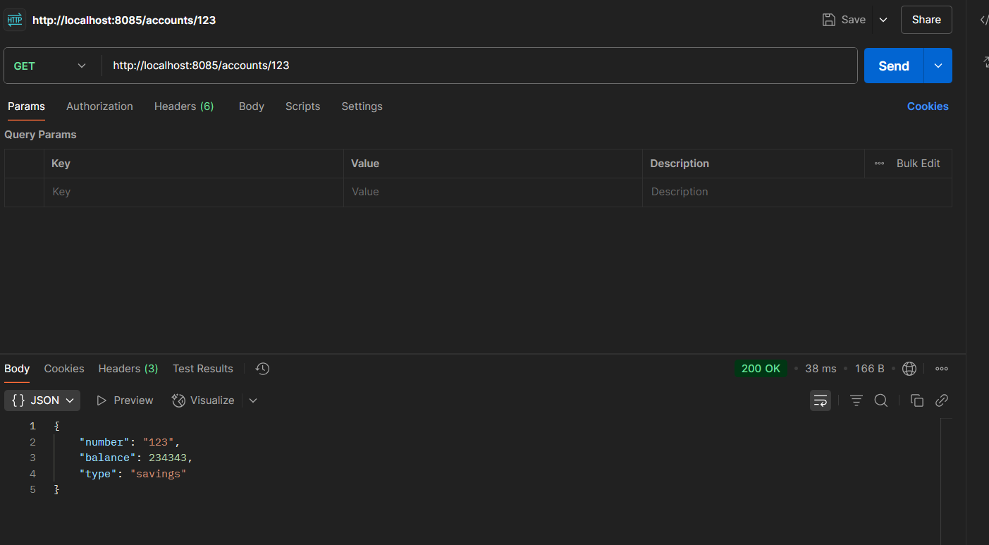

<http://localhost:8085/loans/456>

